Task 16: Incident Response & Security Breach Simulation

1.Simulate a basic security incident such as repeated failed logins or unauthorized access.
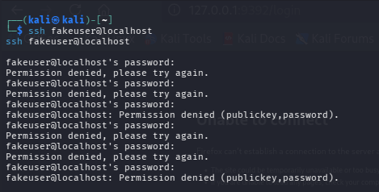
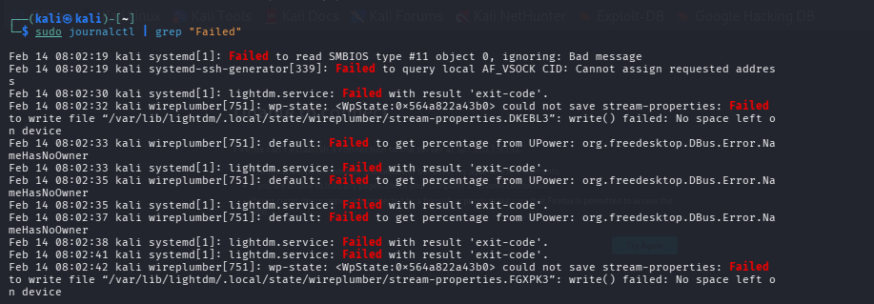

2.Identify suspicious activity by analyzing system and authentication logs.
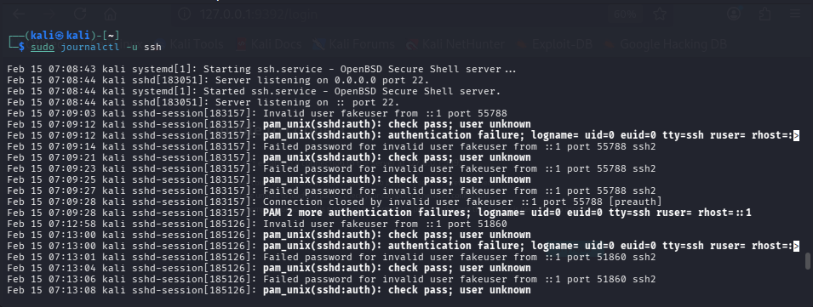
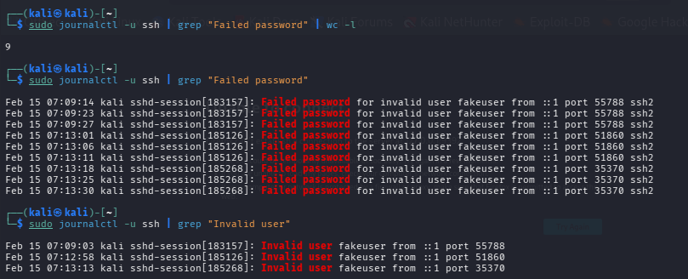
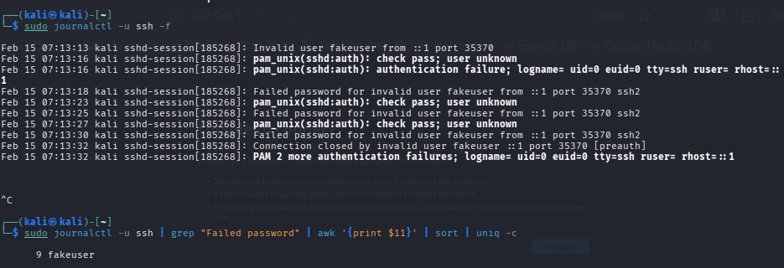

3.Classify the incident based on attack type and severity.
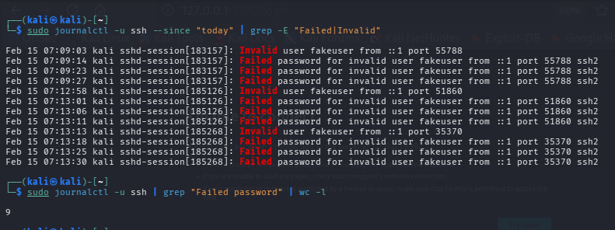
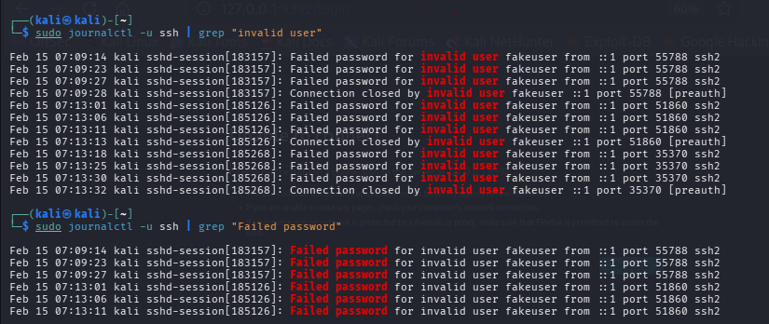
Incident Type: Brute-Force SSH Login Attempt
Detection Source: System Authentication Logs (journalctl)
Indicators:
- Repeated failed password attempts
- Invalid username usage
- Multiple authentication failures
Severity: Low
Reason: Attack unsuccessful; no unauthorized access gained.

4.Contain the incident by isolating affected systems or accounts.
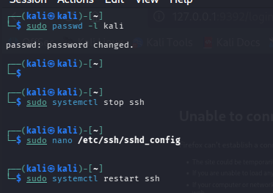
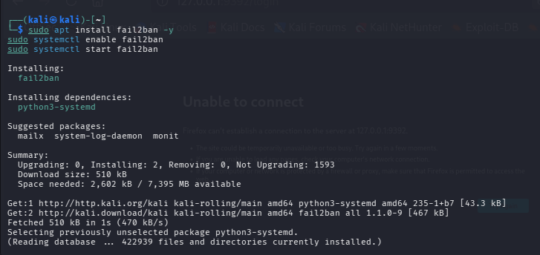
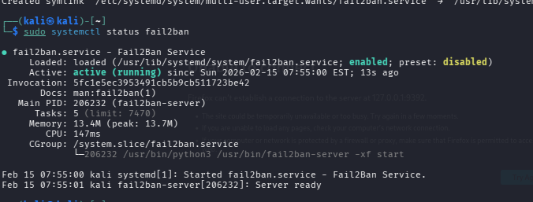

5.Remove the threat and fix the root cause.
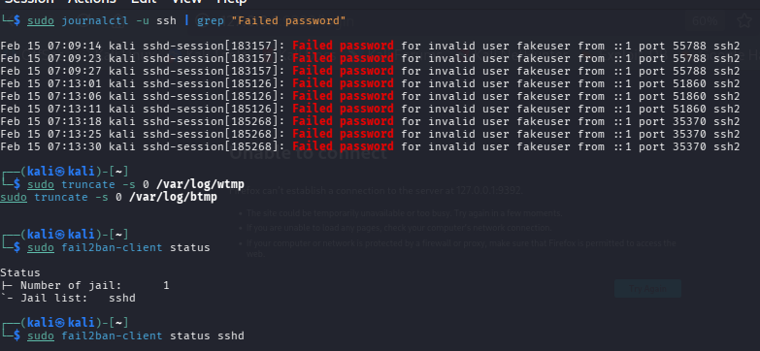
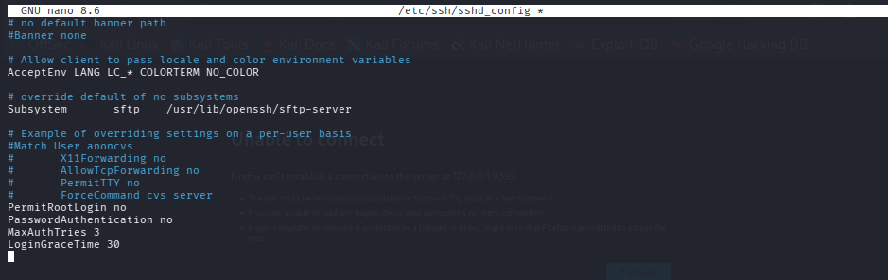
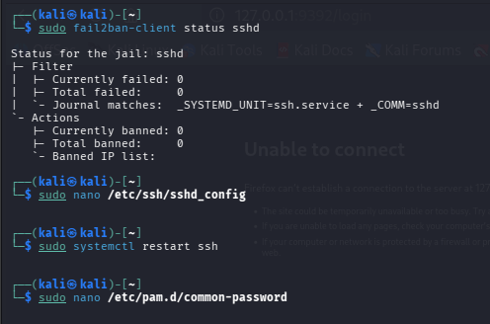
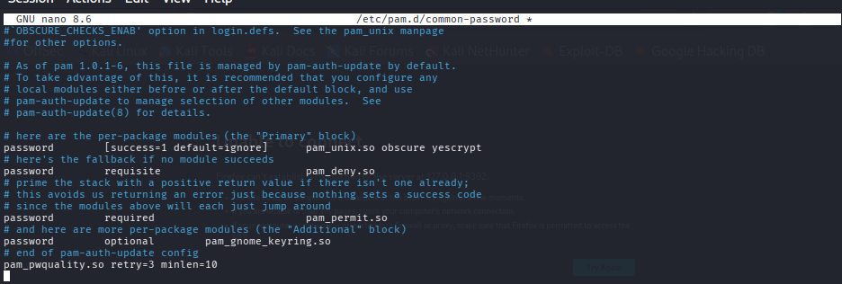

6.Restore systems to a secure state.
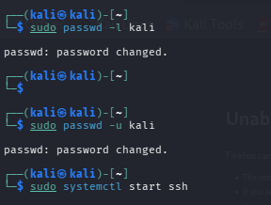
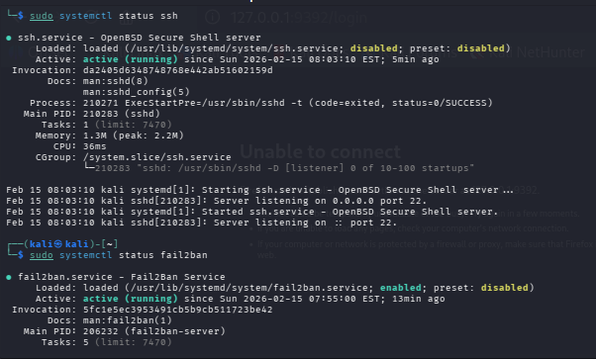
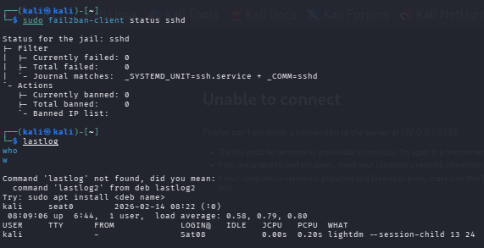
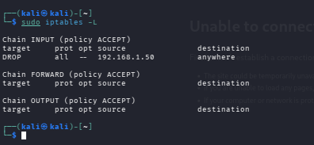

7.Document the incident timeline and actions taken.
Initial Suspicious Activity Detected
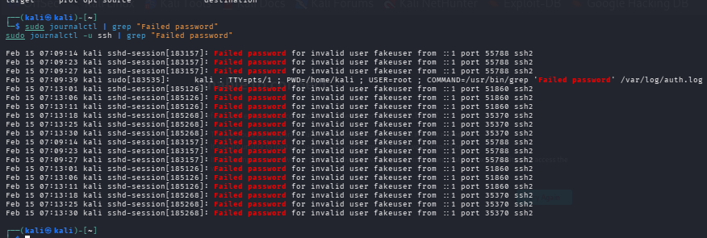

Incident Identification
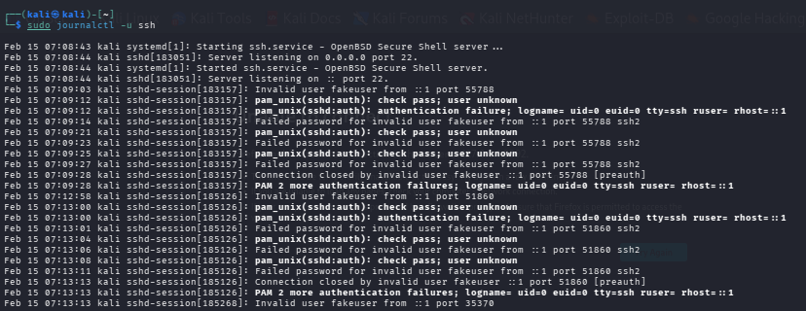

Incident Classification
Type: Brute-force SSH login attempt
Severity: Low (simulated / localhost source)

Containment Actions Taken
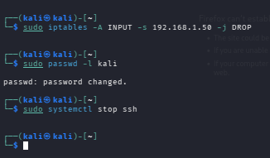

Remediation / Threat Removal
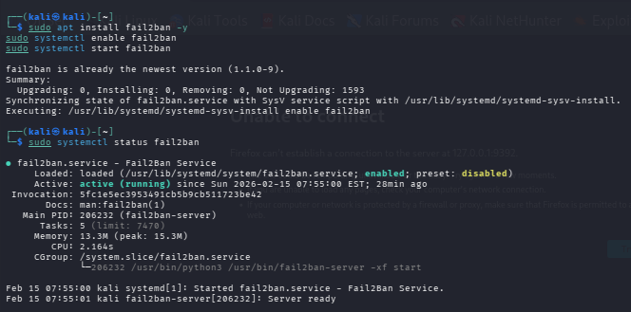

System Recovery
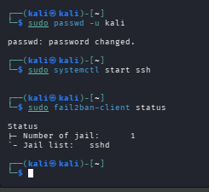

8.Recommend preventive security improvements.
- Strengthen SSH configuration (disable root login, restrict authentication methods)
- Enforce strong password policies (length, complexity, expiration)
- Implement account lockout / login attempt limits
- Deploy automated brute-force protection (e.g., Fail2Ban)
- Apply firewall rules to restrict unauthorized access
- Monitor authentication and system logs regularly
- Enable real-time alerts for suspicious login behavior
- Remove or disable unused user accounts
- Apply regular system updates and security patches
- Conduct periodic vulnerability assessments
- Maintain proper access control and least-privilege principles
- Provide user security awareness training

Conclusion
This incident response simulation demonstrated the practical process of detecting and handling a security event involving repeated failed login attempts. By analyzing authentication logs, suspicious activity was identified and assessed as a potential brute-force attack. Appropriate containment and remediation steps were applied to reduce risk and secure the system.
The exercise emphasized the importance of log monitoring, timely response, and preventive security controls. It provided valuable hands-on understanding of how security incidents are investigated, classified, and resolved in a structured manner.

